Please scan and email completed forms directly to Paul @ pauldailly7@gmail.com or drop off at Brooksbank office by the end of the school day Monday, April 3rd  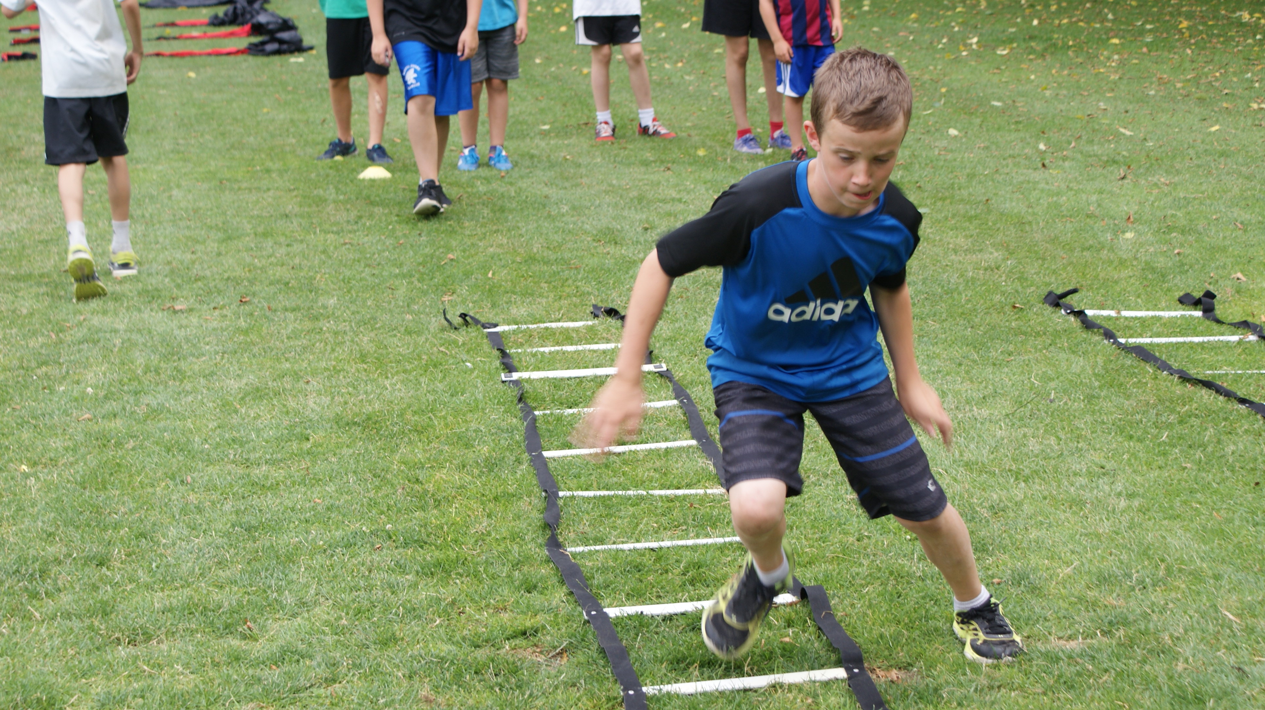  - speed, agility, quickness (Strength and flexibilitY) APRIL 5th – June 7TH  - 10 Weeks –wednesday afternoons @ Brooksbank Elementary Gym or field $175 per person (Open to Grades 2 – 7)  Session 1 – 2:15-3:15pm  An S.A.Q. (Speed, Agility and Quickness) circuit is an exciting and challenging progression for everyone.  Speed - improve your running and movement.  Agility – improve your ability to change direction without compromising balance, co-ordination or technique.  Quickness – improve your reaction time and the initiation of movement.  Please visit our website at www.daillyfitness.ca |  | Ever thought your son or daughter could use some help with their running style?  Improve your son or daughter’s physical literacy  Improve all-around performance and fitness in sports and non-sports persons alike  Certified Instructors with professional and collegiate sport backgrounds  [You Have Room for Another One Here!]  Paul Dailly bhk, nsca, fms  Certified Strength & Conditioning Coach & Former Vancouver Whitecaps Captain  (604)765-4097  pauldailly7@gmail.com  10 Weeks - $175 April 5th- June 7th
*Space is limited and preference will be given in the order registrations are received*

